Assignment 2
Que 1. Write a Java program that calculates the average marks of a student and determines the grade based on the following criteria:
Grade A: Average marks ≥ 90 Grade B: Average marks between 70 and 89
Grade C: Average marks between 50 and 69 Grade D: Average marks between 30 and 49
Fail: Average marks < 30 Predefined Values (Try with different values as well):
● Marks in Maths = 80 ● Marks in Science = 85 ● Marks in History = 90
Expected Output: Average Marks: 85 Grade: B
Ans:
class Average{
public static void main(String[] args){
int math=80;
int sci=85;
int hist=90;
int avg= (math+sci+hist)/3;
System.out.println("Average Marks:" +avg);
if(avg>=90){
System.out.println("Grade A");
}
else if(avg>70 && avg<89){
System.out.println("Grade B");
}
else if(avg>50 && avg<69){
System.out.println("Grade C");
}
else if(avg>30 && avg<49){
System.out.println("Grade D");
}
else{
System.out.println("Fail");
} }}
Output:
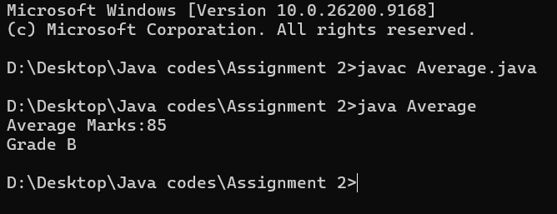

Que 2. Write a Java program that checks whether the year is a leap year or not. A year is a leap year if: It is divisible by 4, but not divisible by 100, or It is divisible by 400.
Predefined Value (Try with different values as well): ● Year = 2024 ● Year = 1900
Expected Output: 2024 is a leap year. 1900 is not a leap year.
Ans:
class LeapYearChek {
public static void main(String[] args) {
int year1 = 2024;
if ((year1 % 4 == 0 && year1 % 100 != 0) || (year1 % 400 == 0)) {
System.out.println(year1 + " is a leap year.");
} else {
System.out.println(year1 + " is not a leap year."); }
int year2 = 1900;
if ((year2 % 4 == 0 && year2 % 100 != 0) || (year2 % 400 == 0)) {
System.out.println(year2 + " is a leap year."); }
else {
System.out.println(year2 + " is not a leap year.");
}}}
Output:
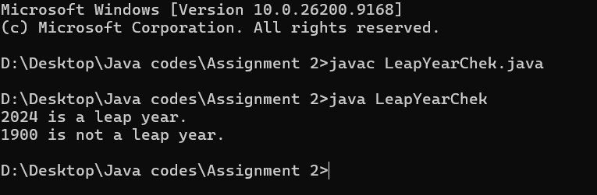

Que 3. Write a Java program that takes an integer between 1 and 7 and prints the corresponding day of the week using a switch-case statement. If the input is outside the range of 1 to 7, the program should display "Invalid day number".
Predefined Value: Day number = 3
Expected Output: The day is Wednesday.
Ans:
class DayOfTheWeek {
public static void main(String args[]) {
int num = 3;
switch(num) {
case 1:
System.out.println("The day is monday");
break;
case 2:
System.out.println("The day is tuesday");
break;
case 3:
System.out.println("The day is wednesday");
break;
case 4:
System.out.println("The day is thursday");
break;
case 5:
System.out.println("The day is friday");
break;
case 6:
System.out.println("The day is saturday");
break;
case 7:
System.out.println("The day is sunday");
break;
default:
System.out.println("Invalid day number");
} } }
Output:
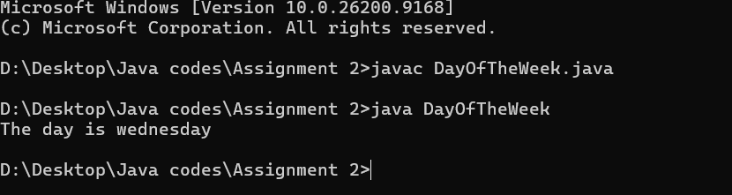

Que 4. You are working on a program that handles different data types. Your manager has asked you to quickly check the values of various variables, but you’re in a rush and forget to initialize them. As you go through the code, you expect some values to show up, but Java has something else in mind. Your task is to fix the issue and ensure the variables hold proper values.
Instructions: 1. Declare the following variables:
byte a;
short b;
int c;
long d;
float e;
double f;
char g;
boolean h;
2. Print out their values.
Ans:
class DataType {
public static void main(String args[]) {
byte a=2;
short b=100;
int c=60000;
long d=987654321L;
float e=10.6F;
double f=10.667;
char g='H';
boolean h= false;
System.out.println(a);
System.out.println(b);
System.out.println(c);
System.out.println(d);
System.out.println(e);
System.out.println(f);
System.out.println(g);
System.out.println(h);
}}

Output:
